CSA0501
DATABASE MANAGEMENT SYSTEMS
LAB EXPERIMENT
S.Mahammed Nayeem
192425294
EXPERIMENT – 10
AIM
To create and perform operations on VIEW and INDEX using the given employees1 relation.
PROCEDURE
- Create the employees1 table with required attributes.
- Insert employee records into the table.
- Create a view named v1 containing employee_id and salary.
- Display the records from the v1 view.
- Insert a record into the view and verify the changes.
- Delete a record from the view and verify the changes.
- Create an index named index1 on the salary attribute.
- Retrieve employees whose salary is above 145000.
- Drop the salary index after completing the operation.
- Create an index named index1 on the employee_id attribute.
- Retrieve the employee whose employee_id is 10.
- Verify the results.
QUESTIONS
1. Create a view named v1 using the employees1 table that contains employee_id and salary.
2. Insert and delete records from the v1 view.
3. Create index1 for the salary attribute and list employees whose salary is above 145000.
4. Create index1 for the employee_id attribute and display the first name of the employee whose employee ID is 10.
Outputs :
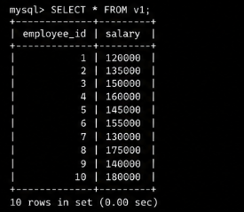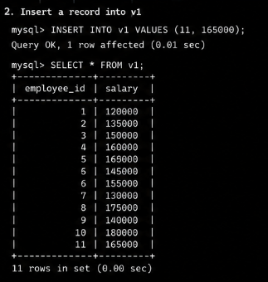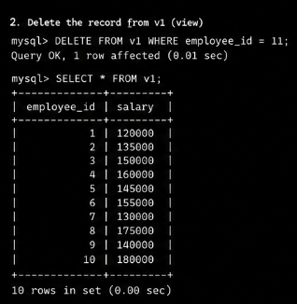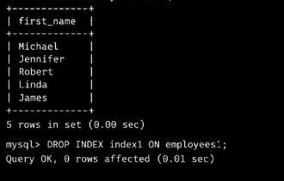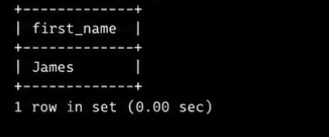

RESULT
Thus, the VIEW and INDEX operations were successfully performed on the employees1 relation. The view was created and modified successfully, and indexes were created and used for faster retrieval of employee records.

